Dokumentasi Report Data Karyawan

Tampilan Report karyawan

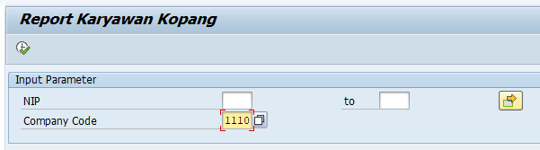

Data report karyawan

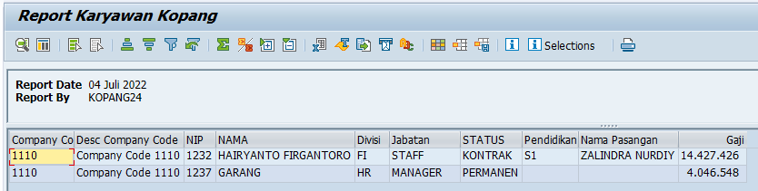

Smarform report data karyawan

